Table of Contents

ABSTRACT 1
CHAPTER 1: INTRODUCTION 2
CHAPTER 2: BLOCK DIAGRAM AND KEY COMPONENTS 4
2.1. BLOCK DIAGRAM 4
2.2. The primary components of the EV BMS include 4
2.3. STM32 Microcontroller 4
2.4. Battery Pack 8
2.5 LCD Display 9
2.6. DHT11 Temperature Sensor 10
2.7. VOLTAGE SENSOR 11
2.8. ACS712 Current Sensor 12
2.9. Relays 12
CHAPTER 3: SYSTEM OPERATION 14
CHAPTER 4: CODE 15
CHAPTER 5: SAFETY IMPLEMENTATION AND TESTING 18
5.1. Testing Procedures 18
5.2. Safety Protocols 18
CHAPATER 6: CONCLUSION &FUTURE ENHANCEMENTS 19
6.1. Project Conclusion 19
6.2. Potential Future Enhancements 19

ABSTRACT

1.INTRODUCTION TO THE PROBLEM:
Electric Vehicles (EVs) are rapidly transforming the global transportation landscape. However, battery-related risks such as overcharging, thermal runaway, and potential fire hazards remain major challenges. The increasing density and energy of lithium-ion batteries demand enhanced Battery Management Systems (BMS) with real-time charge monitoring and integrated fire protection mechanisms to ensure safety, efficiency, and reliability.
2.Project Objective:.
This project aims to design and implement an advanced EV Battery Management System (BMS) that not only monitors battery charge levels with precision but also includes an integrated fire detection and suppression unit. The core objective is to provide a dual-function system—charge monitoring to ensure optimal performance, and proactive fire protection to prevent catastrophic battery failures.
3.System Architecture and Functionality:
The proposed system utilizes voltage and temperature sensors to continuously track individual cell status within the battery pack. A microcontroller-based platform analyzes these parameters to detect anomalies such as overcharging, overheating, or internal short circuits. Upon detecting such risks, the system triggers alerts and activates a fire protection mechanism—using components such as temperature-triggered fire retardants or aerosol-based extinguishers. The design ensures minimal response time and maximized user safety.

4.Innovation and Benefits:
Unlike conventional BMS units, this design combines real-time diagnostics with active safety interventions. It introduces a modular and scalable approach, allowing integration with various EV battery configurations. By addressing both energy management and thermal hazards, the system enhances battery life, prevents damage, and significantly reduces the risk of EV fire incidents.

5.Conclusion and Future Scope:
The EV BMS Charge Monitor and Fire Protection system represents a proactive step towards safer electric mobility. In the future, the system can be enhanced with AI-based predictive analytics and IoT connectivity for remote monitoring and maintenance. This solution offers a critical advancement in EV safety standards and sets the foundation for smarter, more resilient battery systems.

CHAPTER 1: INTRODUCTION

Introduction to Electric Vehicle Battery Management Systems (BMS)

Electric vehicles (EVs) have emerged as a promising solution to the growing concerns over environmental sustainability, reducing carbon emissions, and decreasing dependency on fossil fuels. Central to the performance, safety, and reliability of these electric vehicles is the battery, which powers the entire system. However, the high capacity and complexity of batteries used in EVs demand efficient management systems to ensure optimal operation. This is where the Battery Management System (BMS) plays a critical role.
A Battery Management System is an electronic system that oversees and controls the charging and discharging processes of a battery pack. In an electric vehicle, where large battery packs with multiple cells are employed, the BMS ensures that the battery operates within safe parameters, providing longevity, performance, and safety to the vehicle. A BMS essentially monitors the battery's health, regulates its charge cycles, and protects it from damage due to overcharging, overdischarging, and temperature fluctuations. The design and functionality of a BMS are key to enhancing the efficiency and lifespan of EV batteries.
The Battery Management System (BMS) is a critical component in ensuring the safe and efficient operation of an Electric Vehicle (EV) battery. It monitors and protects the battery pack, maintaining its performance, safety, and longevity. The system integrates several key components, each playing a unique role in maintaining the health of the battery and preventing potential hazards.
At the core of the BMS is the Battery Monitoring Unit (BMU), which acts as the primary sensor and control interface for the system. The BMU is responsible for continuously collecting real-time data from the various sensors to monitor the battery’s health. It tracks key parameters such as voltage, current, and temperature for each individual cell and the overall battery pack. By ensuring that each cell within the battery operates within specified voltage and temperature limits, the BMU plays a crucial role in preventing overcharging or deep discharging, both of which can damage the battery or reduce its lifespan. Moreover, the BMU manages cell balancing, a process that ensures all cells in the battery pack charge and discharge uniformly. This is important because uneven charging or discharging of cells can lead to capacity loss, overheating, and in some cases, fire hazards.
The Central Control Unit (CCU) functions as the brain of the BMS. It processes the data provided by the BMU and makes real-time decisions based on the monitored parameters. The CCU controls the overall charging and discharging cycles of the battery and enforces safety protocols to protect the battery from adverse conditions such as over-voltage, over-current, or excessive temperatures. In addition to managing the battery, the CCU communicates with other vehicle systems, such as the Vehicle Control Unit (VCU) and the Motor Controller, through communication protocols like CAN bus. This allows the BMS to operate in coordination with the vehicle's broader power management system, ensuring optimal energy distribution and system health.
The Voltage, Current, and Temperature Sensors provide essential data that enables the BMS to operate efficiently. Voltage sensors continuously monitor the voltage levels of individual cells as well as the total battery pack voltage. This data is vital in preventing over-voltage and under-voltage conditions, which can cause battery degradation, fires, or even explosion. Current sensors, such as the ACS712 or similar devices, measure the current flowing into and out of the battery during charging and discharging. This information allows the BMS to track the battery’s state of charge (SOC) and manage charging rates, ensuring that the battery is not overcharged or discharged too quickly, both of which can negatively affect its health. Lastly, temperature sensors—such as the DHT11 or other thermistors—measure the temperature at key points within the battery pack. This real-time data ensures that the battery is operating within the optimal thermal range and can trigger cooling systems or safety shutdowns if temperatures exceed safe limits. Overheating is a significant risk in batteries, as it can lead to thermal runaway, a dangerous situation that could cause fires or explosions.

CHAPTER 2: BLOCK DIAGRAM AND KEY COMPONENTS

2.1. BLOCK DIAGRAM

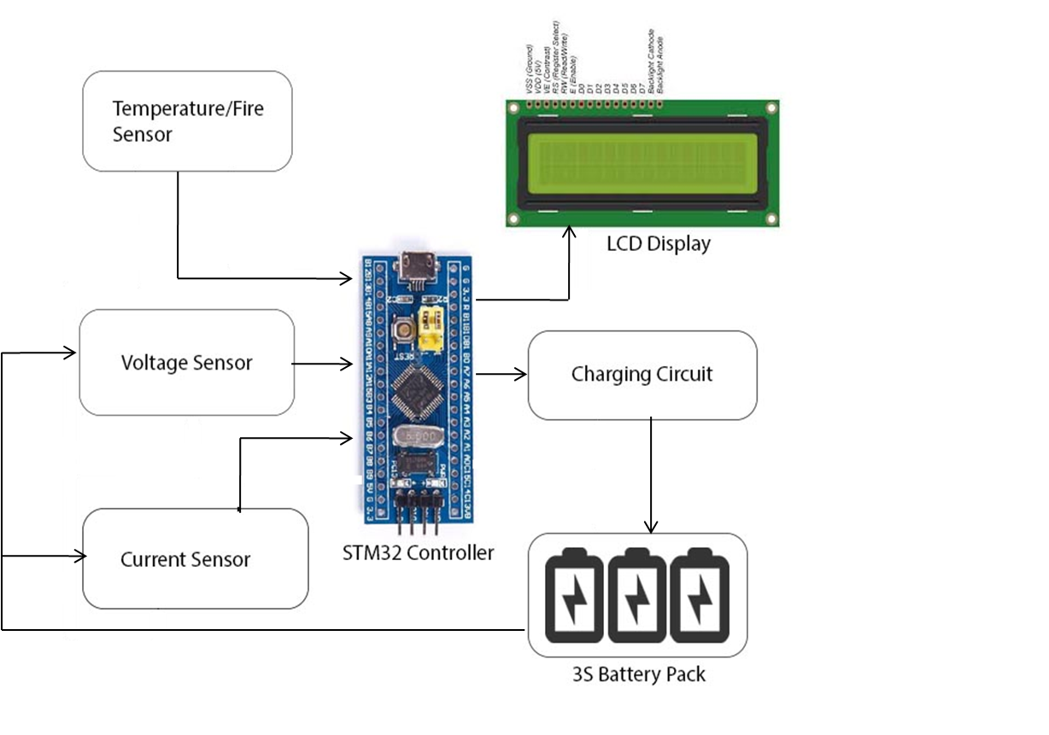

2.2. The primary components of the EV BMS include

- STM32 Microcontroller
- Battery Pack
- LCD Display
- DHT11 Temperature Sensor
- Voltage Sensor
- ACS712 Current Sensor
- Relays

2.3. STM32 Microcontroller

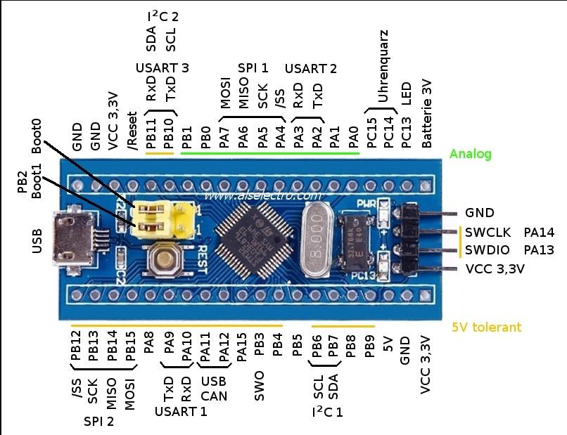
STM32 Microcontroller
2.3.1 Overview:
The STM32 microcontroller is the heart of the BMS, responsible for processing all data from sensors and managing communication between the BMS components. STM32 is a popular microcontroller series based on ARM Cortex-M cores, known for its flexibility, processing power, and efficiency.
2.3.2. Functions:
- Data Processing: The STM32 processes data from the voltage, current, and temperature sensors, and calculates key metrics such as the state of charge (SOC) and state of health (SOH) of the battery.
- Control and Decision Making: Based on the processed data, it manages battery charging/discharging, balances cells, and implements safety protocols like over-voltage, under-voltage, and temperature limits.
- Communication: It communicates with other subsystems in the EV through protocols like CAN bus or I2C for remote monitoring, diagnostics, and control.
2.3.3 Benefits:
- High processing power for real-time data handling.
- Low power consumption, ideal for embedded systems like BMS.
- Flexible I/O options for interfacing with sensors and relays.
2.3.4 Features include:
- High Performance, Low Power Design
- 8-Bit Microcontroller Atmel® AVR® advanced RISC architecture
  - 131 Instructions most of which are executed in a single clock cycle
  - Up to 20 MIPS throughput at 20 MHz
  - 32 x 8 working registers
  - 2 cycle multiplier
- Memory Includes
  - 32KB of of programmable FLASH
  - 1KB of EEPROM
  - 2KB SRAM
  - 10,000 Write and Erase Cycles for Flash and 100,000 for EEPROM
  - Data retention for 20 years at 85°C and 100 years at 25°C
  - Optional boot loader with lock bits
    - In System Programming (ISP) by via boot loader
    - True Read-While-Write operation
  - Programming lock available for software security
- Features Include
  - 2 x 8-bit Timers/Counters each with independent prescaler and compare modes
  - A single 16-bit Timer/Counter with an idependent prescaler, compare and capture modes
  - 10 bit, 6 channel analog to digital Converter
  - 6 pulse width modulation channels
  - Internal temperature sensor
  - Serial USART (Programmable)
  - Master/Slave SPI Serial Interface – (Philips I2C compatible)
  - Programmable watchdog timer with independent internal oscillator
  - Internal analog comparator
  - Interrupt and wake up on pin change
- Additional Features
  - Internal calibrated oscillator
  - Power on reset and programmable brown out detection
  - External and internal interrupts
  - 6 sleep modes including idle, ADC noise reduction, power save, power down, standby, and extended standby;
- I/O and Package
  - 23 programmable I/O lines
  - 28 pin PDIP package
- Operating voltage:
  - 1.8 – 5.5V
- Operating temperature range:
  - 40°C to 85°C
- Speed Grades:
  - 0-4 MHz at 1.8-5.5V
  - 0-10 MHz at 2.7-5.5V
  - 0-20 MHz at 4.5-5.5V
- Low power consumption mode at 1.8V, 1 MHz and 25°C:
  - Active Mode: 0.3 Ma
  - Power-down Mode: 0.1 Μa
  - Power-save Mode: 0.8 Μa (Including 32 kHz RTC)

2.4. Battery Pack
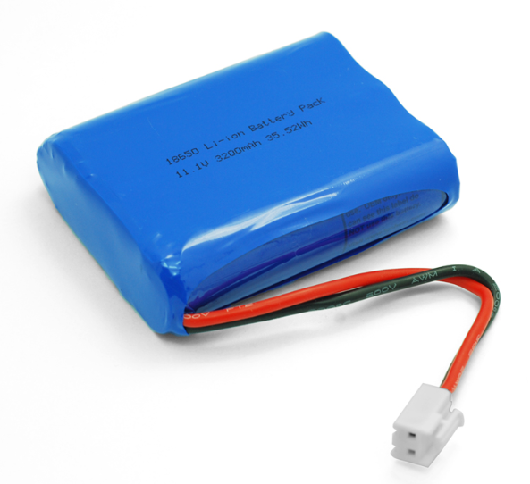
2.4.1. Overview:
The battery pack is the core power source for the EV. It consists of multiple individual battery cells arranged in series and parallel to provide the required voltage and capacity. The BMS monitors and manages the health of each cell to ensure the pack’s safe operation.
2.4.2. Functions:
- Voltage and Current Monitoring: The BMS tracks each cell’s voltage and the overall battery pack’s current.
- Cell Balancing: The BMS ensures all cells in the pack are balanced, meaning they charge and discharge at similar rates, preventing over-discharge or overcharge of individual cells.
4.3. Battery Safety:
- The BMS triggers safety mechanisms when a cell exhibits abnormal behavior (e.g., over-voltage, under-voltage, or overcurrent).
- Temperature Monitoring: Ensures cells do not overheat, which can lead to fires or degradation.

2.5 LCD Display
2.5.1. Overview:
The LCD Display offers a human-machine interface (HMI) that provides real-time information on battery parameters, warnings, and system status.
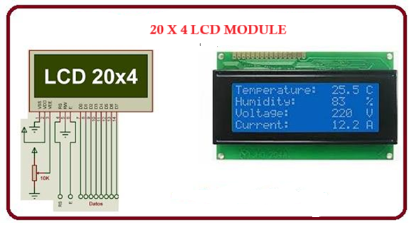

2.5.2. Specifications:

- Type: 16x2 or 20x4 character displays, with options for graphical LCDs depending on requirements.
- Interface: Parallel or I2C based; I2C modules simplify wiring and free up I/O pins on the STM32.
- Operating Voltage: Typically 5V (with level shifting if needed for 3.3V systems)
- Backlight: LED backlit for visibility in varying lighting conditions
- Refresh Rate: Adequate for real-time updates (typically less than 250 ms latency)

2.5.3. Function in the System:

- Data Visualization: Display battery voltage, current, temperature, SOC (State of Charge), and alerts.
- User Feedback: Show status messages during startup, operation, safety events, and reset conditions.

2.6. DHT11 Temperature Sensor

2.6.1. Overview:
The DHT11 is a simple, low-cost digital sensor for measuring ambient temperature and humidity. In an EV, monitoring temperature is critical to prevent thermal runaway.
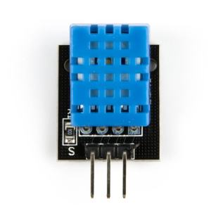

2.6.2. Specifications:

- Temperature Range: 0°C to 50°C (with ±1°C accuracy)
- Humidity Range: 20% to 90% RH (accuracy ±5% typically; ±1% for temperature)
- Operating Voltage: 3.5V to 5.5V
- Interface: Single-wire digital interface; requires precise timing for data communication

2.6.3. Role in the EV BMS:

- Thermal Monitoring: Checks ambient and battery temperature and sends warnings if thresholds are exceeded.
- Fire Protection: Helps in early detection of thermal events that may lead to fire.

2.7. VOLTAGE SENSOR
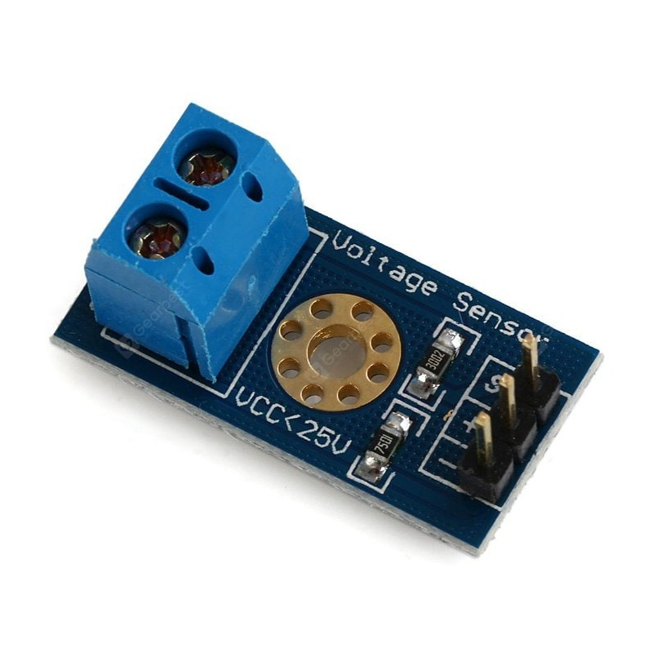

2.7.1 Overview:
Voltage sensors are used to monitor the voltage of individual battery cells and accumulate data for the entire battery pack. Accurate voltage measurement is essential for charge balancing and safety.

2.7.2. Specifications:

- Measurement Range: Designed to cover the operating voltage of the battery pack (e.g., 0V to 60V, depending on the design)
- Accuracy: Typically within ±0.1V or better when calibrated properly
- Interface: Analog output connected to the ADC channels of STM32
- Calibration: May require voltage dividers and reference stabilization to ensure precision

2.7.3. Role in the System:

- Monitoring: Continuously tracks battery cell voltages to ensure balance and detect anomalies.
- Control: Data is fed into the STM32 for processing charge/discharge operations and triggering safety measures.

2.8. ACS712 Current Sensor

2.8.1. Overview:
The ACS712 is a popular hall-effect based linear current sensor that provides an analog voltage output proportional to the sensed current.
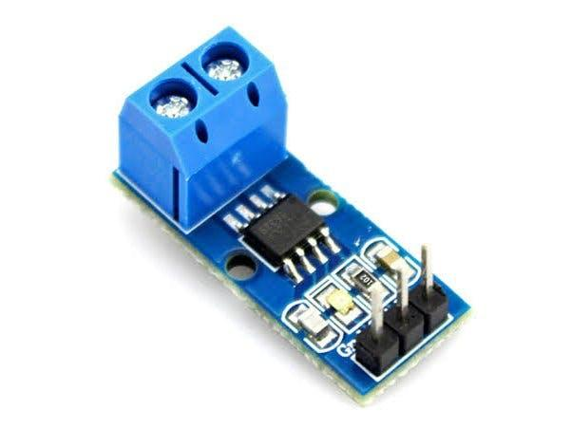

2.8.2. Specifications:

- Versions/Ranges: Available in ±5 A, ±20 A, and ±30 A variants
- Sensitivity:
- 185 mV/A for ±5 A
- 100 mV/A for ±20 A
- 66 mV/A for ±30 A
- Frequency Response: Suitable for both AC and DC measurements
- Isolation: Provides electrical isolation between the measured current and the output signal
- Interface: Analog output that feeds into the ADC on the STM32

2.8.3. Role in the EV BMS:

- Current Monitoring: Ensures that charging and discharging currents remain within safe limits.
- Protective Control: In case of overcurrent conditions, the STM32 can trigger relay controls to disconnect the battery, thus preventing potential damage or fire.

2.9. Relays

2.9.1. Overview:
Relays are electrically operated switches used within the system to disconnect or isolate the battery under unsafe conditions
.

2.9.2. Specifications:

- Types:
- SPDT (Single Pole Double Throw): Common for switching between two circuits
- DPDT (Double Pole Double Throw): For more complex switching scenarios
- Voltage and Current Ratings:
- Typically rated for 12V or 24V DC operation for control circuits
- Current ratings can vary; in EV applications, relays rated at 10A or above are common
- Operational Integrity: Must work reliably under rapid switching conditions, especially when triggered by safety algorithms

2.9.3. Role in the System:

- Safety Actuation: When the STM32 detects overcharge, overcurrent, or over-temperature conditions, the relays disconnect the battery pack to prevent hazardous events.
- Load Management: Can also be used to manage different battery segments or auxiliary loads.

CHAPTER 3: SYSTEM OPERATION

Data Acquisition & Processing Flow:

1. Initialization:
- The STM32 boots up, initializing all peripheral interfaces.
- LCD displays a welcome screen and system self-check results.
2. Sensor Polling:
- ADC channels continuously sample voltage and ACS712 current sensor data.
- The DHT11 sensor is polled at regular intervals, ensuring fresh temperature readings.
3. Real-Time Processing:
- Sensor data is processed in the main loop and through interrupt service routines.
- The microcontroller compares data against predefined alarm thresholds.
4. User Display & Alerts:
- Processed data (voltage, current, temperature, SOC) is sent to the LCD.
- Visual and audible alerts are triggered if any parameter deviates from safe limits.

CHAPTER 4: CODE

#include "stm32f1xx.h"
#include "lcd.h"
#include "dht11.h"
#include "adc.h"

// Pin configuration
#define BUZZER_PIN GPIO_PIN_0
#define RELAY_PIN GPIO_PIN_1
#define LED_CHARGE GPIO_PIN_2
#define LED_DISCHARGE GPIO_PIN_3
#define MOTOR_PIN GPIO_PIN_4

// Thresholds
#define VOLTAGE_THRESHOLD 12.0
#define CURRENT_THRESHOLD 5.0
#define TEMPERATURE_THRESHOLD 50.0

void SystemClock_Config(void);
void GPIO_Config(void);
void CheckSensors(float voltage, float current, int temperature);

int main(void)
{
HAL_Init();
SystemClock_Config();
GPIO_Config();
LCD_Init();
DHT11_Init();
ADC_Init();

while (1)
{
float voltage = ADC_ReadVoltage();
float current = ADC_ReadCurrent();
int temperature = DHT11_ReadTemperature();

LCD_Clear();
LCD_Print("V: %.2fV", voltage);
LCD_Print("I: %.2fA", current);
LCD_Print("T: %dC", temperature);

CheckSensors(voltage, current, temperature);
HAL_Delay(1000);
}
}

void GPIO_Config(void)
{
__HAL_RCC_GPIOA_CLK_ENABLE();
GPIO_InitTypeDef GPIO_InitStruct = {0};

// Configure GPIO pins for buzzer, relay, LEDs, and motor
GPIO_InitStruct.Pin = BUZZER_PIN | RELAY_PIN | LED_CHARGE | LED_DISCHARGE | MOTOR_PIN;
GPIO_InitStruct.Mode = GPIO_MODE_OUTPUT_PP;
GPIO_InitStruct.Pull = GPIO_NOPULL;
GPIO_InitStruct.Speed = GPIO_SPEED_FREQ_LOW;
HAL_GPIO_Init(GPIOA, &GPIO_InitStruct);
}

void CheckSensors(float voltage, float current, int temperature)
{
if (voltage > VOLTAGE_THRESHOLD || current > CURRENT_THRESHOLD || temperature > TEMPERATURE_THRESHOLD)
{
HAL_GPIO_WritePin(GPIOA, BUZZER_PIN, GPIO_PIN_SET); // Activate buzzer
HAL_GPIO_WritePin(GPIOA, RELAY_PIN, GPIO_PIN_SET); // Shut down relay
LCD_Print("ALERT: Unsafe Conditions!");
}
else
{
HAL_GPIO_WritePin(GPIOA, BUZZER_PIN, GPIO_PIN_RESET);
HAL_GPIO_WritePin(GPIOA, RELAY_PIN, GPIO_PIN_RESET);
LCD_Print("System Normal");
}
}

CHAPTER 5: SAFETY IMPLEMENTATION AND TESTING

5.1. Testing Procedures

- Unit Testing:
Each sensor (voltage, current, temperature) is calibrated and tested individually.
- Integration Testing:
Validate the communication between the STM32 and monitors (LCD, sensors) ensuring accurate real-time data transfer.
- Fault Simulation:
Intentionally trigger over-voltage, over-current, and overtemperature conditions in a controlled environment to test relay actuation and system alerts.
- Long-Term Reliability:
Continuous operating tests to ensure that the firmware handles prolonged operation without memory leaks or CPU overutilization.

5.2. Safety Protocols

- Thermal Protection:
+ Continuous monitoring using DHT11; if temperature exceeds thresholds, the system isolates the battery with relays.
- Overcurrent Protection:
+ ACS712 readings are monitored to detect current spikes.
+ Relays disengage loads or charging circuitry when anomalies are detected.
- Voltage Imbalance:
+ Voltage sensors monitor each cell, and if imbalance is noted, the system may enable balancing circuits or trigger warnings for maintenance.
- Fallback Mechanisms:
+ Default safe mode routines ensure that in case of sensor failure or firmware error, the system defaults to a disconnected battery state.

CHAPATER 6: CONCLUSION &FUTURE ENHANCEMENTS

6.1. Project Conclusion

The EV BMS with Charge Monitor and Fire Protection represents a robust solution tailored for electric vehicle applications. By integrating the STM32 microcontroller with multiple reliable sensors (DHT11, voltage sensors, ACS712) and control elements (relays, LCD display), the system not only monitors battery health but actively intervenes in hazardous situations. The modular design allows for continuous improvements and integration of additional features.

6.2. Potential Future Enhancements

- Wireless Connectivity:
+ Integration of Bluetooth or Wi-Fi modules to send real-time alerts to mobile devices.
- Advanced Data Logging:
+ Incorporate SD card storage or cloud integration for historical data analysis.
- Enhanced User Interface:
+ Use graphical LCD or TFT displays for more detailed interface visuals.
- Predictive Maintenance Algorithms:
+ Utilize machine learning on historical data to forecast battery health issues.
- Integration with Vehicle Systems:
+ Allow bidirectional communication with the EV’s central control for integrated vehicle telemetry.

